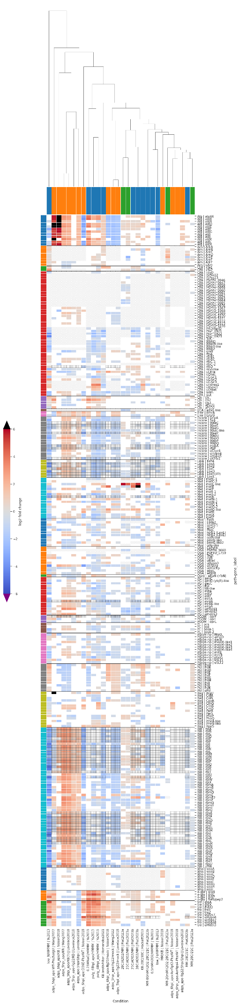**Supplementary data**

**Figure S1** - master transcriptomics heatmap. The columns each show a paper and interrogated condition in the same format as the main text. The bars at the top are coloured by strain, with blue being B728a, orange being DC3000 and green being 1448a. The dendogram at the top is responsible for column ordering, and is based on similarity between the conditions using sns.clustermap. However, this clustering is likely biased by N/A values and empty cells as it is based on all the rows present. Each row gives a gene, with the associated pathway/function given as well. Genes starting with u have no given name in available databases, but the hypothetical function is abbreviated in the name – see Table S1 for functional information. Rows are ordered by functional category. Log2 fold change in expression values are indicated in the squares, with blank squares if the adjusted p-value is less than 0.05 or if the gene was not detected. Diagonal hashing indicates the gene is not present in the strain studied, while grid hashing indicates the gene was essential – essentiality information is only available for B728a and DC3000. Genes with greater than 6 log2 fold change in expression are masked in black. Data is amalgamated from (Hernandez & Lindow, 2021; Hockett et al., 2013; Lovelace et al., 2018; Nobori et al., 2018; Piat et al., 2023; Wang et al., 2022; Yu et al., 2013)with essentiality from (Helmann, Deutschbauer, et al., 2019; Yang et al., 2025).

**Figure S2** - master Tnseq heatmap. The conditions are indicated as obtained from <http://fit.genomics.lbl.gov/>, where the results of (Helmann, Deutschbauer, et al., 2019; Helmann et al., 2020; Helmann, Ongsarte, et al., 2019) were deposited. Squares are coloured based on fitness values, with blank squares indicating the associated t-value was less than 2.5. As above, columns indicate different conditions, but here technical and biological replicates are uncombined with the vertical lines grouping experiments under the same conditions. Each row corresponds to a gene, no essential genes are present as they would not feature in the initial transpon insertion library.

**Figure S3** - full OD600 curves for Silwet. Each cell corresponds to the OD readout from an individual well in a 96-well plate. The percentage of silwet present in each well is given to the left, while the x axis shows the time in hours post incubation start. Vertical lines group technical replicates of the conditions indicated above, namely strains DC3000, B782a or blank wells. The left panel shows the first replicate, and the right the second with an additional strain and fewer technical replicates. In the first replicate, well 8E was excluded as an anomaly.

**Figure S4** - full OD600 curves for divalent ion levels. Each cell shows the OD600 in a single well of 96 well plate with 3 biological replicates; 1 in red, 2 in black and 3 in blue. Major divalent ion concentrations are given to the left, with minor ion concentration being 20 fold lower. The identity of the major ion in each set of 3 technical replicates is given at the top. The left 6 columns correspond to B728a, and the right DC3000, with the bottom 2 rows being blanks. In the second replicate (black), minimal growth was observed in columns 7 and 8, and in cells 1D-6D, which does not fit with the other samples in that study or with the other replicates, so these values were excluded from subsequent analysis. Dashed vertical lines show the 24 hour time point.

**Figure S5** - full OD600 curves for chelators. Each cell gives the OD600 value from a single well in a 96-well plate. 3 plates are represented, corresponding to the same conditions for strains B728a, DC3000 and 1448a; note that for DC3000 a different plate reader was used and the final time was only 24 hours. 24 hours is marked on the axes of all graphs with a dashed vertical line. The blue vertical lines separate technical replicates, for each plate subdividing High divalent ion (2 mM Mg2+) citrate and EDTA from low divalent ion (0.4 mM). The concentration of chelators is given to the left, with the bottom two rows being cellular blanks. The same trends in growth impact are observed in all strains.

**Supplementary references**

Helmann, T. C., Deutschbauer, A. M., & Lindow, S. E. (2019). Genome-wide identification of Pseudomonas syringae genes required for fitness during colonization of the leaf surface and apoplast. *Proceedings of the National Academy of Sciences of the United States of America*, *116*(38), 18900–18910. https://doi.org/10.1073/pnas.1908858116

Helmann, T. C., Deutschbauer, A. M., & Lindow, S. E. (2020). Distinctiveness of genes contributing to growth of Pseudomonas syringae in diverse host plant species. *PLoS ONE*, *15*(9 September). https://doi.org/10.1371/journal.pone.0239998

Helmann, T. C., Ongsarte, C. L., Lam, J., Deutschbauer, A. M., & Lindow, S. E. (2019). Genome-wide transposon screen of a pseudomonas syringae mexB mutant reveals the substrates of efflux transporters. *MBio*, *10*(5). https://doi.org/10.1128/mBio.02614-19

Hernandez, M. N., & Lindow, S. E. (2021). Contact-dependent traits in Pseudomonas syringae B728a. *PLOS ONE*, *16*(2), e0241655. https://doi.org/10.1371/journal.pone.0241655

Hockett, K. L., Burch, A. Y., & Lindow, S. E. (2013). Thermo-Regulation of Genes Mediating Motility and Plant Interactions in Pseudomonas syringae. *PLoS ONE*, *8*(3). https://doi.org/10.1371/journal.pone.0059850

Lovelace, A. H., Smith, A., & Kvitko, B. H. (2018). Pattern-triggered immunity alters the transcriptional regulation of virulence-associated genes and induces the sulfur starvation response in pseudomonas syringae pv. tomato DC3000. *Molecular Plant-Microbe Interactions*, *31*(7), 750–765. https://doi.org/10.1094/MPMI-01-18-0008-R

Nobori, T., Velásquez, A. C., Wu, J., Kvitko, B. H., Kremer, J. M., Wang, Y., He, S. Y., & Tsuda, K. (2018). Transcriptome landscape of a bacterial pathogen under plant immunity. *Proceedings of the National Academy of Sciences of the United States of America*, *115*(13), E3055–E3064. https://doi.org/10.1073/pnas.1800529115

Piat, J., Preston, G., Pritchard, L., Kruger, N., & Fricker, M. (2023). *Transcriptome of bacterial pathogens of common bean exposed to hydrogen peroxide at 21°C and 28°C.* . University of Oxford. https://doi.org/http://dx.doi.org/10.5287/ora-mzjqbogqm

Wang, H., Smith, A., Lovelace, A., & Kvitko, B. H. (2022). In planta transcriptomics reveals conflicts between pattern-triggered immunity and the AlgU sigma factor regulon. *PLoS ONE*, *17*(9 September). https://doi.org/10.1371/journal.pone.0274009

Yang, Z., Helmann, T., Baudin, M., Schreiber, K. J., Bao, Z., Stodghill, P., Deutschbauer, A., Lewis, J. D., & Swingle, B. (2025). Genome-wide identification of novel flagellar motility genes in Pseudomonas syringae pv. tomato DC3000. *Frontiers in Microbiology*, *16*. https://doi.org/10.3389/fmicb.2025.1535114

Yu, X., Lund, S. P., Scott, R. A., Greenwald, J. W., Records, A. H., Nettleton, D., Lindow, S. E., Gross, D. C., & Beattie, G. A. (2013). Transcriptional responses of Pseudomonas syringae to growth in epiphytic versus apoplastic leaf sites. *Proceedings of the National Academy of Sciences of the United States of America*, *110*(5). https://doi.org/10.1073/pnas.1221892110